There are two type of server:

1. Web Profile Servers
2. Full Profile Servers or Application Servers

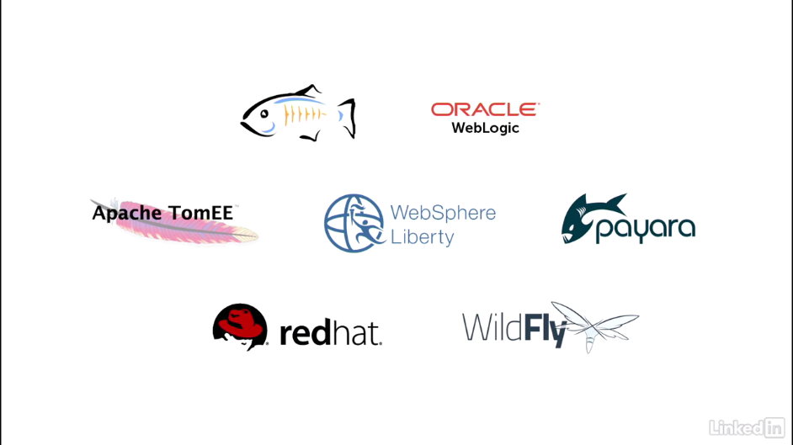

**Application Servers**: A Full Profile Server or Application Server support the full Java EE features, means it supports all the APIs of Java EE as shown below:

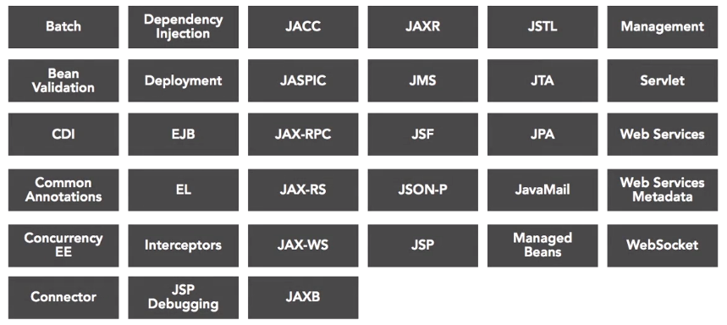

**Web Profile Servers:** Web Profile Servers is a light weight container. They are only able to run the Core APIs of JAVA EE. They mostly support 18 APIs of JAVA EE. Tomcat is the best example of Web Profile Server. Lightweight and Very Fast.